P E S University
Model Paper
UE18CS251 :Design and Analysis of Algorithms
Time: 3 Hrs. Answer All Questions Max Marks: 100

1 | a | An algorithm is a sequence of unambiguous instructions for solving a problem, i.e., for obtaining a required output for any legitimate input in a finite amount of time.  [2 Marks]
1 | b | ALGORITHM PrimeNumber(n)  //Determines the primality of a number  //Input: An integer n  //Output: True or False  for i <- 2 to n/2 do  if n % i == 0  return True  return False  [4 Marks]
1 | c | A function t(n) is said to be in O(g(n)) if t(n) is bounded above by some constant multiple of g(n) for all large n, i.e., if there exist some positive constant ‘c’ and some non - negative integer n₀ such that t(n) <= cg(n) for all n >= n₀. [2 Marks]  A function t(n) is said to be in Ω(g(n)) if t(n) is bounded below by some constant multiple of g(n) for all large n, i.e., if there exist some positive constant ‘c’ and some non - negative integer n₀ such that t(n) >= cg(n) for all n >= n₀. [2 Marks]  100n², 123, 1200n³, 3n belong to O(n²) [2 Marks]
1 | d | ALGORITHM Maximum (A[n])  //This algorithm determines the maximum number in the given list of numbers  //Input: An array containing integers  //Output: The maximum integer in the list  max <- 0  for i <- 0 to n-1 do  if A[i] > A[max]  max <- i  return A[max]  [4 Marks]  Basic Operation: if A[i] > A[max]  [1 MARK]  C(n) = n-1  Σ 1 = (n - 1) - 0 +1 = n  i=0  [2 Marks]  This algorithm belongs to 𝜣(n)  [1 Mark]
2 | a | 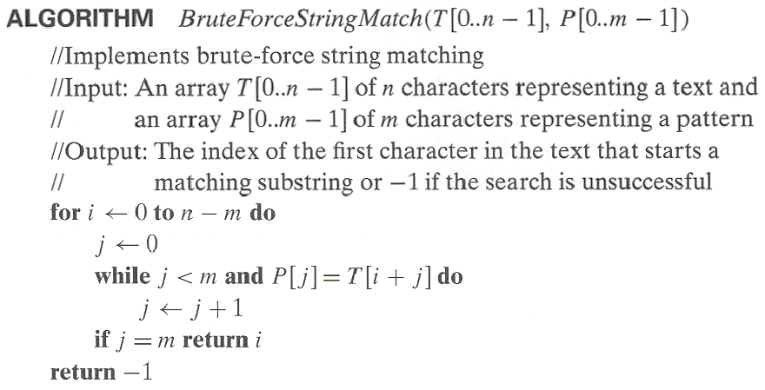  Example:  T r u t h _ a l w a y s _ t r i u m p h s  w a y s - First character mismatch  T r u t h _ a l w a y s _ t r i u m p h s  w a y s - First character mismatch  T r u t h _ a l w a y s _ t r i u m p h s  w a y s - First character mismatch  T r u t h _ a l w a y s _ t r i u m p h s  w a y s - First character mismatch  T r u t h _ a l w a y s _ t r i u m p h s  w a y s - First character mismatch  T r u t h _ a l w a y s _ t r i u m p h s  w a y s - First character mismatch  T r u t h _ a l w a y s _ t r i u m p h s  w a y s - First character mismatch  T r u t h _ a l w a y s _ t r i u m p h s  w a y s - First character mismatch  T r u t h _ a l w a y s _ t r i u m p h s  w a y s - First character mismatch  [3 marks - Algorithm, 2 marks - Example]
2 | b | The worst - case efficiency of bubble sort is 𝜣(n²). [1 Mark]  ALGORITHM BubbleSort(A[0..n-1])  //Sorts a given array by Bubble Sort  //Input: An array A[0..n-1] of orderable elements  //Output: Array A[0..n-1] sorted in ascending order  for i <- 0 to n-2 do  for j <- i+1 to n-2-i do  if A[j] > A[j+1]  swap A[j] and A[j+1]  [4 marks - Algorithm]
2 | c | i) The Divide and Conquer algorithm design strategy divides a problem into smaller instances of same problem, solves the smaller instances recursively and merges the solution. [2 marks]  ii) Preorder, Inorder, Postorder [1 mark]  iii) Merge Sort, Quick Sort [2 marks]
2 | d | Python Java Ruby Perl JavaScript Haskell Pascal  Haskell Java Ruby Perl JavaScript Python Pascal  Haskell Java Ruby Perl JavaScript Python Pascal  Haskell Java JavaScript Perl Ruby Python Pascal  Haskell Java JavaScript Pascal Ruby Python Perl  Haskell Java JavaScript Pascal Perl Python Ruby  Haskell Java JavaScript Pascal Perl Python Ruby  [5 Marks]
3 | a | The Breadth First Search Traversal of the given graph is:  A B C D E F G [3 Marks]  The differences between DFS and BFS are:  [3 Marks]
  DFS | BFS
  Uses Stack data structure | Uses Queue data structure
  Has 2 vertex orderings | Has 1 vertex ordering
  Has tree edges and back edges | Has tree edges and cross edges
3 | b | Many problems involving lists are easier when list is sorted. Sorting a list before solving the problem is called presorting. [1 Mark]  Presorting belongs to the Representation Change variation of Transform and Conquer. [1 Mark]  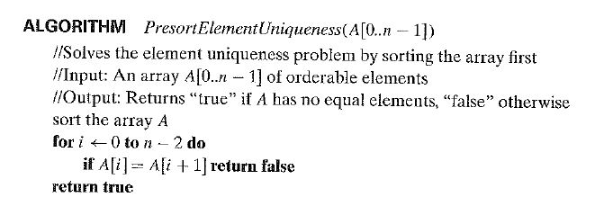  [4 Marks]
3 | c | i) Multiplication a la Russe [2 Marks]  Let n and m be positive integers whose product we want to compute, and let us measure the instance size by the value of n. Now, if n is even, an instance of half the size has to deal with n/2, and we have an obvious formula relating the solution to the problem's larger instance to the solution to the smaller one:  n*m = (n/2)*2m  If n is odd, we need only a slight adjustment of this formula:  n*m = ((n-1)/2)*2m+m.  Using these formulas and the trivial case of 1*m = m to stop, we can compute product n*m either recursively or iteratively.  ii) AVL Trees [2 Marks]  An AVL tree is a binary search tree in which the balance factor of every node, which is defined as the difference between the heights of the node's left and right subtrees, is either 0 or + 1 or -1. (The height of the empty tree is defined as -1.). If an insertion of a new node makes an AVL tree unbalanced, we transform the tree by a rotation. A rotation in an AVL tree is a local transformation of its subtree rooted at a node whose balance has become either +2 or -2.
 | d | 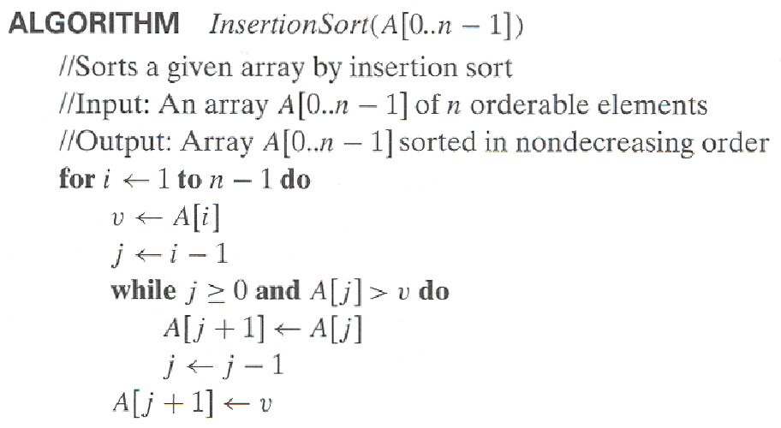  [4 Marks]
4 | a | H o n e s t y _ i s _ t h e _ b e s t _ p o l i c y  p o l i c y  H o n e s t y _ i s _ t h e _ b e s t _ p o l i c y  p o l i c y  H o n e s t y _ i s _ t h e _ b e s t _ p o l i c y  p o l i c y  H o n e s t y _ i s _ t h e _ b e s t _ p o l i c y  p o l i c y  H o n e s t y _ i s _ t h e _ b e s t _ p o l i c y  p o l i c y  [3 Marks - Shift Table, 5 Marks - Tracing]
  P | O | L | I | C | Y | A-B, D-H, J-K, M-N, Q-W, Z
  5 | 4 | 3 | 2 | 1 | 6 | 6
4 | b | Hashing is based on the idea of distributing keys among a one-dimensional array H[O .. m- 1] called a hash table. The distribution is done by computing, for each of the keys, the value of some predefined function h called the hash function. This function assigns an integer between 0 and m - 1, called the hash address, to a key. If we choose a hash table's size m to be smaller than the number of keys n, we will get collisions-a phenomenon of two (or more) keys being hashed into the same cell of the hash table. every hashing scheme must have a collision resolution mechanism. This mechanism is different in the two principal versions of hashing: Open Hashing (also called separate chaining) and Closed Hashing (also called open addressing).  In open hashing, keys are stored in linked lists attached to cells of a hash table. Each list contains all the keys hashed to its cell.  In closed hashing, all keys are stored in the hash table itself without the use of linked lists. (Of course, this implies that the table size m must be at least as large as the number of keys n.) Different strategies can be employed for collision resolution. The simplest one-called linear probing-checks the cell following the one where the collision occurs. If that cell is empty, the new key is installed there; if the next cell is already occupied, the availability of that cell's immediate successor is checked, and so on. Note that if the end of the hash table is reached, the search is wrapped to the beginning of the table; that is, it is treated as a circular array.
4 | c | ALGORITHM Kruskal(G)  //Kruskal’s algorithm for constructing a minimum spanning tree  //Input: A weighted connected graph G = (V, E)  //Output: E_{T}, the set of edges composing a minimum spanning tree of G  sort E in nondecresing order of the edge weights w(e_{i1}) <= ….. <= w(e_{i|E|})  ET <- ɸ; ecounter <- 0  k <- 0  while ecounter < |V| - 1 do  k <- k + 1  if E_{T} U {e_{ik}} is acyclic  E_{T} <- E_{T} U {e_{ik}}; ecounter <- ecounter + 1  return E_{T}  [4 Marks]
 | d | Dynamic Programming is a technique of solving problems with overlapping sub problems. Typically, these subproblems arise from a recurrence relating a solution to a given problem with solutions to its smaller subproblems of the same type. Rather than solving the same subproblems again and again, dynamic programming suggests solving each of the smaller subproblems only once and recording the results in a table.  [2 Marks]  Computer scientists consider greedy technique as a general design technique despite the fact that it is applicable to optimization problems only. The greedy approach suggests constructing a solution through a sequence of steps, each expanding a partially constructed solution obtained so far, until a complete solution to the problem is reached. On each step-and this is the central point of this technique-the choice made must be feasible, i.e., it has to satisfy the problem's constraints, locally optimal, i.e., it has to be the best local choice among all feasible choices available on that step and irrevocable, i.e., once made, it cannot be changed on subsequent steps of the algorithm. These requirements explain the technique's name: on each step, it suggests a "greedy" grab of the best alternative available in the hope that a sequence of locally optimal choices will yield a (globally) optimal solution to the entire problem.  [2 Marks]
5 | a | i) Problems that can be solved in polynomial time are tractable problems. Problems that cannot be solved in polynomial time are intractable problems.  ii) Class P is a class of decision problems that can be solved in polynomial time by deterministic algorithms. Ex: Bubble Sort  iii) A nondeterministic algorithm is a two-stage procedure that takes as its input an instance I of a decision problem and does the following.  Nondeterministic ("guessing") stage: An arbitrary string S is generated that can be thought of as a candidate solution to the given instance I (but may be complete gibberish as well).  Deterministic ("verification") stage: A deterministic algorithm takes both I and S as its input and outputs yes if S represents a solution to instance I. (If S is not a solution to instance I, the algorithm either returns no or is allowed not to halt at all). We say that a nondeterministic algorithm solves a decision problem if and  only if for every yes instance of the problem it returns yes on some execution.  iv) A decision problem D is said to be NP - complete if it belongs to class NP and every problem in NP is polynomially reducible to D.  A decision problem D1 is said to be polynomially reducible to a decision problem D2 if there exists a function t that transforms instances of D1 to instances of D2 such that t maps all yes instances of D1 to yes instances of D2 and all no instances of D1 to no instances of D2 and t is computable by a polynomial time algorithm.  [2 Marks]

